**1. Total Revenue:**

SELECT SUM(total_price) AS Total_Revenue FROM pizza_sales_data;

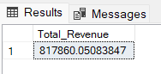

**2. Average Order Value**

SELECT (SUM(total_price) / COUNT(DISTINCT order_id)) AS Avg_order_Value FROM pizza_sales_data;

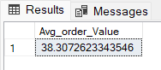

**3. Total Pizzas Sold**

SELECT SUM(quantity) AS Total_pizza_sold FROM pizza_sales_data;

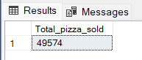

**4. Total Orders**

SELECT COUNT(DISTINCT order_id) AS Total_Orders FROM pizza_sales_data;

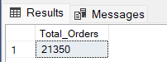

**5. Average Pizzas Per Order**

SELECT CAST(CAST(SUM(quantity) AS DECIMAL(10,2)) /

CAST(COUNT(DISTINCT order_id) AS DECIMAL(10,2)) AS DECIMAL(10,2))

AS Avg_Pizzas_per_order

FROM pizza_sales_data;

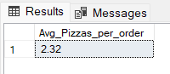

**More data analysis requirements:**

1.Daily Trend for Total Orders:

Analyse how the total number of orders changes on a daily basis.

2.Hourly Trend for Total Orders:

Investigate the hourly fluctuations in the total number of orders.

3.Percentage of Sales by Pizza Category:

Determine the proportion of sales attributed to each pizza category.

4.Percentage of Sales by Pizza Size: Calculate the percentage distribution of sales based on different pizza sizes.

5.Total Pizzas Sold by Pizza Category:

Examine the overall quantity of pizzas sold within each pizza category.

6.Top 5 Best Sellers by Total Pizzas Sold:

Identify the top 5 pizzas that have the highest total sales.

7.Bottom 5 Worst Sellers by Total Pizzas Sold:

Identify the bottom 5 pizzas with the lowest total sales.

**B. Daily Trend for Total Orders:**

**1.Daily total orders:**

SELECT DATENAME(DW, order_date) AS order_day, COUNT(DISTINCT order_id) AS total_orders

FROM pizza_sales_data

GROUP BY DATENAME(DW, order_date);

***Output:***

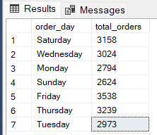

**2. Hourly Trend for Orders:**

SELECT DATEPART(HOUR, order_time) as order_hours, COUNT(DISTINCT order_id) as total_orders

from pizza_sales_data

group by DATEPART(HOUR, order_time)

order by DATEPART(HOUR, order_time);

***Output***

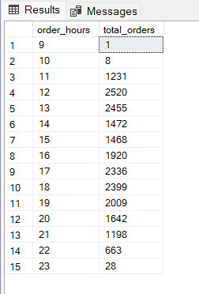

**3. % of Sales by Pizza Category:**

SELECT pizza_category, CAST(SUM(total_price) AS DECIMAL(10,2)) as total_revenue,

CAST(SUM(total_price) * 100 / (SELECT SUM(total_price) from pizza_sales) AS DECIMAL(10,2)) AS PCT

FROM pizza_sales_data

GROUP BY pizza_category;

***Output***

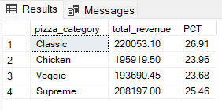

**4.% of Sales by Pizza Size:**

SELECT pizza_size, CAST(SUM(total_price) AS DECIMAL(10,2)) as total_revenue,

CAST(SUM(total_price) * 100 / (SELECT SUM(total_price) from pizza_sales) AS DECIMAL(10,2)) AS PCT

FROM pizza_sales_data

GROUP BY pizza_size

ORDER BY pizza_size

***Output***

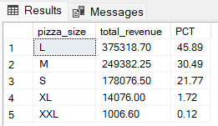

**5.Total Pizzas Sold by Pizza Category:**

SELECT pizza_category, SUM(quantity) as Total_Quantity_Sold

FROM pizza_sales_data

WHERE MONTH(order_date) = 2

GROUP BY pizza_category

ORDER BY Total_Quantity_Sold DESC

***Output***

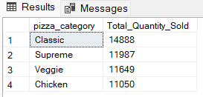

**6.Top 5 Best Sellers by Total Pizzas Sold:**

SELECT Top 5 pizza_name, SUM(quantity) AS Total_Pizza_Sold

FROM pizza_sales_data

GROUP BY pizza_name

ORDER BY Total_Pizza_Sold DESC

***Output***

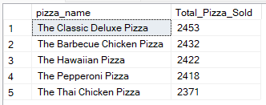

**7.Bottom 5 Best Sellers by Total Pizzas Sold:**

SELECT TOP 5 pizza_name, SUM(quantity) AS Total_Pizza_Sold

FROM pizza_sales_data

GROUP BY pizza_name

ORDER BY Total_Pizza_Sold ASC

***Output***

